A multi-model design of fractional order predictive functional control
Weide Xu ¹, Dawei Wang ¹, Jili Tao², Ridong Zhang ¹
- Key Lab for IOT and Information Fusion Technology of Zhejiang, Information and Control Institute, Hangzhou Dianzi University, Hangzhou, 310018, P.R. China
E-mail: xwd822@163.com, 13750895763@163.com, zrd-el@163.com
2. Ningbo Institute of Technology, Zhejiang University, Ningbo, 315100, China
E-mail: tjl810@126.com

Abstract: TO cope with the existence of large operation range, time-delay and nonlinearity in the industrial processes, a multi-model design of fractional order predictive functional control is presented. In this paper, the controlled system is divided into a series of models on the basis of working conditions. Then the set of local approximate models are obtained by decomposing the nonlinear process dynamics. The accuracy of predictive function control system is improved by establishing the fractional order models. In addition, the influence of the nonlinearity in the process is reduced by the weighting of the control variables of each linear model. Finally, the performance of designed controller is verified through a fractional order system in a heating furnace.
Keyword: multi-models, predictive functional control, fractional order systems

- Introduction
With the development of science and technology, industrial processes are becoming more and more complex. In the industrial processes, nonlinearity, large time delay and other aspects of design must be taken into account for improved control performance.
Model predictive control is an advanced control, which employs a process model to predict the future changes of the process via a prediction strategy. Therefore it has received a lot of attention and also has been applied in practice. In [1], an application of nonlinear MPC with a dead time compensator to control a distributed solar collector is presented. An input-output feedback linearization scheme for doubly-induction generators has been proposed in [2]. In [3], a PFC scheme has been applied efficiently on the parallel mechanisms. In [4], The PFC is applied to the chemical reactors in distributed control systems. These strategies were efficiently employed for industrial process control systems with the disturbance rejection and tracking performance [5,6].
However, MPC suffers from the insufficient precision of offline identified modes for nonlinear systems. Multiple model control strategy is effective for processes with strong nonlinearity if the nonlinear process dynamics can be separated into sets of the approximation models [7-8]. In [9] a switching multi-model predictive control strategy is used for vehicle with strong nonlinearity. In [10], a multiple models is combined with Bayes theorem for nonlinear systems. In [11] a multiple adaptive switching control system is proposed. In order to improve the accuracy of the models, the fractional order system is presented [12]. In [13, 14], generalized predictive controllers based on fractional order cost functions were established to adjust the disturbance performance of the systems. In [15], a fractional numerical approximation method was solved through MPC controller. The Oustaloup approximation strategies are proposed in fractional predictive controllers designs [16]. The fractional order MPC method has been implemented in industrial processes in [17].
This paper proposes a multimode fractional PFC and is summarized as follows. Section 2 introduces the design of a multi-model of fractional order predictive control, and the local fractional order model is transformed into integer order model though the Outsaloup method. Then the PFC based on the integer model is formulated. Last an method to calculate the weight of each local models control variables is proposed. In section 3, the algorithm is applied to heating furnace process and compared with traditional method. Section 4 gives the conclusions.

2. The multi-model design of fractional order predictive control
2.1 Fractional order model
In the traditional control theory, the model of a process is considered as an integer order system. However the dynamics of the system can be described by the fractional order system more accurately. The fractional order system in industrial processes can be described as follows:
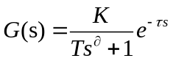 (1)
whereis the fractional order of the system,,,are the process gain, time constant and delay time respectively.
The fractional order operator of the model can be transformed into a corresponding integer equation through the Oustaloup approximation method.
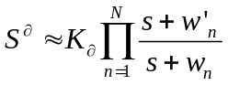 (2)

where，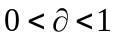is the fractional order, 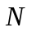is the approximation limit that relies on the orders of high order integer transfer function approximated by the fractional derivative operator,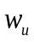 and 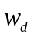are the upper and lower of frequency approximation interval.
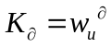,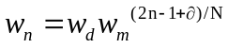,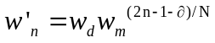,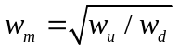.
Through adding a zero-order holder at the sample time, the process model can be transformed into a differenced equation model:
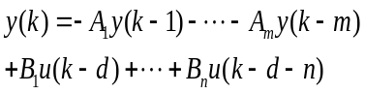 (3)
whereis the time delay, 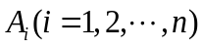, 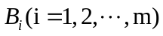are the coefficients of the discrete model.
2.2 Predictive function control
In order to reduce the error between the model and the process, the differenced operator is added into the discrete model. Then the process can been described as:
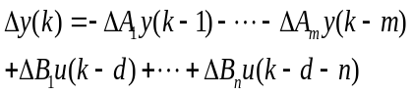 (4)
The state variable is denoted as
The state space model is derived:
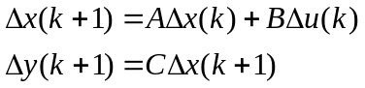 (5)

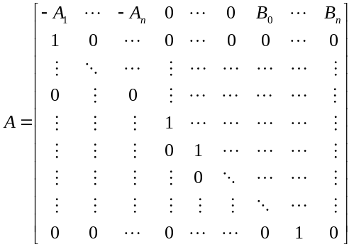
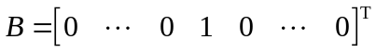
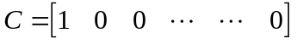
The tracking error can be described as:
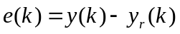 (6)
where 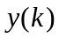,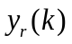are the process output and predictive output at current time.
For simplicity, we choose the step function as the basic function for PFC:
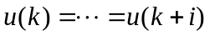 (7)
The reference trajectory is chosen as:
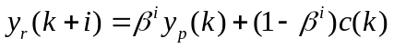 (8)
Therefore the future step error can be derived as:
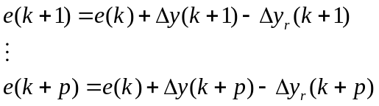 (9)

The optimal cost function will be selected as
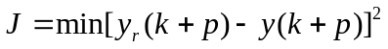 (10)
By minimizing the cost function, the optimal control law can be obtained:
(11)
where,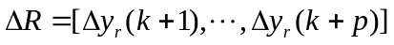,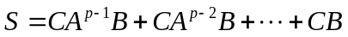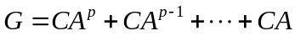

2.3 The weighted coefficient of multi-model
The error between the output of the future model and the plant is a good criterion to evaluate the system's performance. The local model mismatch is achieved as follows:
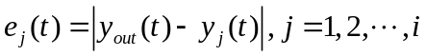 (12)

According to the error of the local model, we can calculate the weighted coefficient of each part.
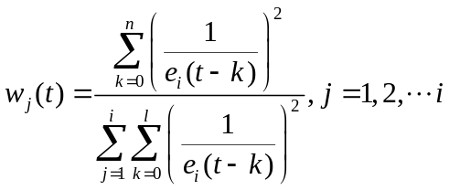 (13)

The weights are acquired immediately as shown in (equation13).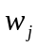 represents the weight of the control variables for the 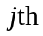 local region. The brief method to calculate the weight is based on error of the plant model mismatch. Here, is a value between 0 and 1, the summation of all weights is equal to 1. It uses the past history of residuals and a speculation is assigned to each model to calculate the weight.
The weighting of the control variables for each linear model is calculated to reconstitute the overall control variables through a conventional method. Thus, the objective control variables can be written as:
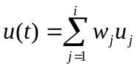 (14)

3. Case study
In this section, the multi-model design of fractional order predictive control will be applied to a heating furnace.
3.1 The principle of the furnace temperature
The workflow of the heating furnace temperature control is shown as follows:
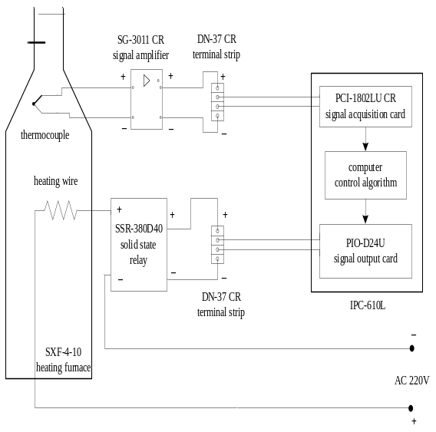
Fig. 1. The heating furnace.
The thermocouple is used to measure the temperature and generate a voltage signal. The voltage will be amplified through the signal amplifier SG-3011CR and be examined by the PCI-1802LU CR signal acquisition card, which transforms the voltage signal into digital signal for the industrial processing computer(IPC). IPC is an intermediate part in which the temperature data is collected from PCI-1802LU CR card and the heating time of furnace is controlled. The heating time for the furnace temperature is implemented by the SSR-380D40 solid state relay, which transforms the corresponding voltage signal to the on-off state signal. When the output of the IPC is 0x01, the PIO-D24U signal output card will produce +5V output signal for the SSR-380D40 solid state relay. On the contrary, if the output signal of the IPC is 0x00, the voltage of PIO-D24U signal output card will be 0 V, then the SFX 4-10 electric heating furnace is not on the heating state.

3.2 The fractional model of each regions
The objective temperature is set as 300℃ and it will be divided into two sections. The models for the two sections can be obtained by setting the temperature set point as 150℃ and 300℃ respectively and collecting the temperature data.
When the set-point of the temperature is changed to 150℃the fractional order model of the heating furnace is described as:
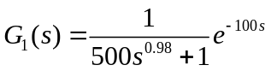 (15)

When the set-point temperature is changed from 150℃ to 300℃, the fractional order model of the heating furnace is described as:
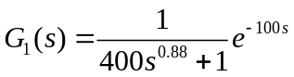 (16)

According to the Oustaloup approximation method, the order of the operators is chosen as 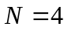 , the upper and lower of frequency approximation interval are chosen 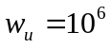 and 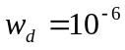.the Oustaloup approximation model can be derived as:
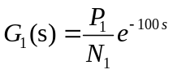 (17)
where:
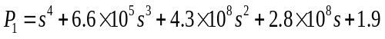

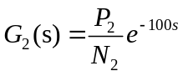 (18)
where:
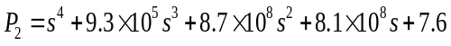
The step response of the practical model, the fractional model and the Oustaloup approximation model is shown in Fig2.
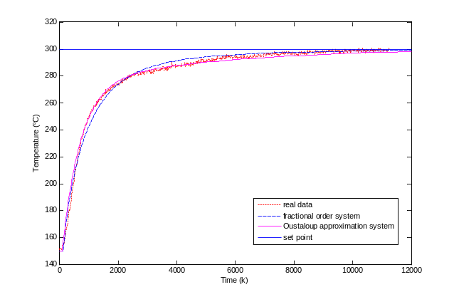
Fig. 2. The step responses of first model.

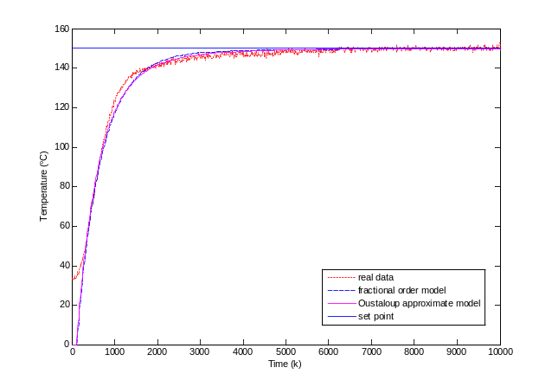
Fig. 3. The step responses of second model.

3.3 The performance of multi-model fractional order predictive controller
To verify the performance of the proposed Multi mode PFC (MMFPFC), a comparison with standard PFC and FPFC is completed. Here the predictive horizon is chosen as 20 and the smoothing factor is 0.98. The tracking performance of the setpoint 300℃ is shown in Fig.4. The faster responses are obtained from the FPFC, the proposed MMFPFC and the PFC are compared with the classical control of PID. It can be seen from the response of MMFPFC is the fastest. There is a litter overshoot in the response of PFC strategy when it reaches the set value. The FPFC is very fast in the early stage of the control process, but when the temperature is close to the set value, the speed will slow down. The PID control in these trials is the slowest compared with other methods.
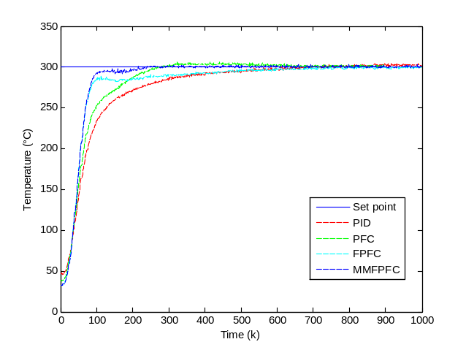
Fig. 4. The responses of close-loop system.

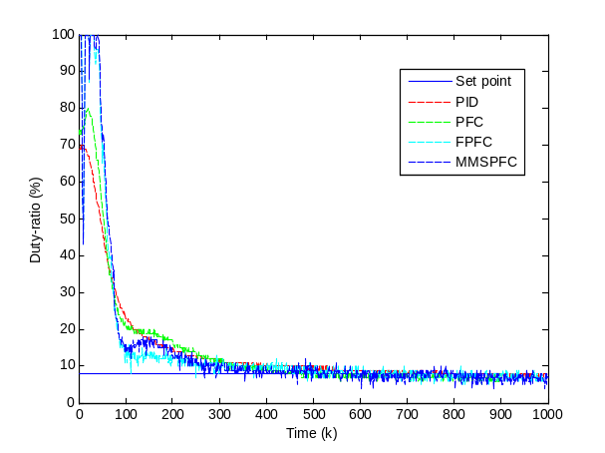
Fig. 5. The duty ratio of input signal.

In order to compare the steady respone of the system, we extract 1000 sets of data from the system after it reached at the set point as shown in table 1. The average, maximum, minimum, system variance and standard are shown. The control results show the improved performance of the proposed MMFPFC strategy.
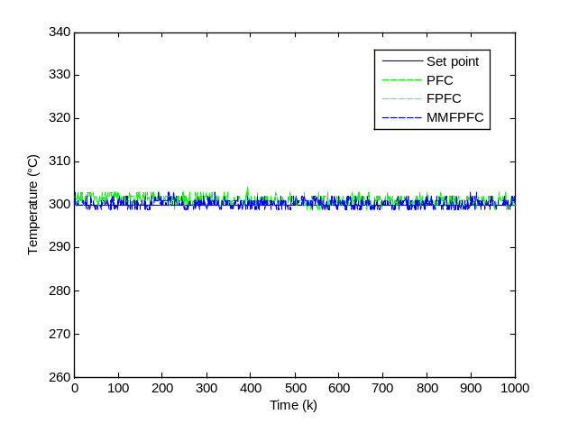
Fig. 6. The stability of system.

Table.1. The data from the system stability
Algorithm | MMFPFC | FPFC | PFC
Average | 300.047 | 299.599 | 301.109
Maximum | 302 | 302 | 305
Minimum | 299 | 298 | 298
Variance | 0.83969 | 0.748947 | 0.922041
Standard  deviation | 0.92718 | 0.86541 | 0.96022

4.Conclusion
In the paper, a multi-model design of fractional order predictive control is proposed and applied in the heating furnace. The nonlinear process plant is decomposed into the approximated linear models in which the Oustaloup approximation method is used, then the corresponding PFC controller is designed. The proposed MMFPFC algorithm is applied in the heating furnace to verify its performance. The experimental results on the heating furnace process indicated the ascendency of the proposed MMFPFC method.
References
[1] Manuel. G. C, Robin. D. K, Clara. I, Nonlinear predictive control with dead-time compensator: Application to a solar power plant. Solar Energy, 83, 743-752, 2009.
[2] Liu. X. J, Kong. X. B, Nonlinear model predictive control for DFIG based wind power generation, IEEE Transaction on automation science and engineering, 11(4), 1046-1055, 2014.
[3] Vivas. A, &Poignet. P, Predictive functional control of a parallel robot, Control Engineering Practice, 13(7), 863-874, 2005.
[4] Zhang. Q. L, & Wang. S. Q, Studies and applications of predictive functional control in temperature tracking of chemical reactors, Control Theory & Applications, 4, 018, 2001.
[5] Zhang, R., Zou, H., Xue, A., Gao, F, GA based predictive functional control for batch processes under actuator faults, Chemometrics and Intelligent Laboratory Systems, 137:67-73, 2014.
[6] Zhang, R., Cao,Z., Bo, C., Li,P., Gao, F, New PID controller design using extended non-minimal state space model based predictive functional control structure, Industrial & Engineering Chemistry Research, 53(8):3283-3292, 2014.
[7] Wu, S., Zhang, R., Lu, R., Gao, F, Design of dynamic matrix control based PID for residual oil outlet temperature in a coke furnace, Chemometrics and Intelligent Laboratory Systems, 134:110-117, 2014.
[8] Zhang, R., Wu, S., Gao, F, Improved PI controller based on predictive functional control for liquid level regulation in a coke fractionation tower, Journal of Process Control,24(3):125-132, 2014.
[9] Chen. H, Li. N, Li. S. Y, Switching multi-model predictive control for hypersonic vehicle, In:8th Asian Control Conference, 677-681, 2011.
[10] Nandola, N. N., Bhartiya, S. A multiple model approach for predictive control of nonlinear hybrid systems. Journal of Process Control, 18, 131–148, 2008.
[11] Giovanini. L, Ordys. A. W, Grimble. M. J, Adaptive predictive control using multiple models, switching and tuning, International Journal of Control Automation and Systems, 4(6): 669, 2006.
[12]M. Ö. Efe, Fractional order systems in industrial automation—a survey, Industrial Informatics, IEEE Transactions on, 7(4), 582-591, 2011.
[13] Romero. M, Madrid. A. P. de, Mañoso. C, Milanes. V, Vinagre. B. M, Fractional-order generalized predictive control: Application for low-speed control of gasoline-propelled cars, Mathematical Problems in Engineering, 2013.
[14]Romero. M, Madrid. A. P. de, Mañoso. C, Vinagre. B. M, Fractional order generalized predictive control: Formulation and some properties, In 11th International Conference on Control, Automation, Robotics and Vision, Sigapore, 1495-1500, 2010.
[15]Rhouma. A., Bouzouita. B, Bouani. F, Model predictive control of fractional systems using numerical approximation, In World Symposium on Computer Applications and Research, 1-6, 2014.
[16] Zou, Q., Jin, Q., Zhang, R, Design of fractional order predictive functional control for fractional industrial processes, Chemometrics and Intelligent Laboratory Systems, 152: 34-41, 2016.
[17] Deng. Z, Cao. H, Li. X, Jiang. J, Yang. J, Qin. Y, Generalized predictive control for fractional order dynamic model of solid oxide fuel cell output power, Journal of Power Sources, 195(24), 8097-8103, 2010.

